STUDENT MANAGEMENT & RESULT

PROCESSING SYSTEM

A Project Report submitted to the

Department of Computer Science and Engineering, Hajee Mohammad Danesh Science and Technology University in partial fulfillment of the requirements for Database Course of

B.Sc. (Engineering) in Computer Science and Engineering

By

Mohadeb Kumar

Student ID: 1702047

Session: 2017

Litu Anam Bochon

Student ID: 1602018

Session: 2017

Pankaj Roy

Student ID:1602019

Session:2016

Zakir Hossain

Student ID:1602019

Session:2016

Submitted To

Md. Nahid Sultan

Assistant Professor



DEPARTMENT OF COMPUTER SCIENCE AND ENGINEERING

HAJEE MOHAMMAD DANESH SCIENCE AND TECHNOLOGY UNIVERSITY, DINAJPUR-5200, BANGLADESH

**Objective of the project**

“The aim of this project is to maintain student’s information, processing their result and.”

* General objective
* **Personal skill development**

The goal is to develop knowledge such as competitive intelligence. In many cases, knowledge is an objective but not an end goal.

* **Business goal**

The other goal is to build up a software company in near future by gaining of software development knowledge.

* **Human expectation and satisfaction experiment**

The another goal is to make user happier and to improve user satisfaction rates.

* Specific objective
* The main goal is to develop knowledge and skills and learn how to work as a team.
* Another main goal is to provide automation to the school.

**Inspiration of this project**

Some of my friends and I went to our memorable primary school to see my elder brother’s information and result. There we found a problem. Our school management don’t use digital solution. We don’t know why our school management don’t use modern solutions for modern problems and our ministry don’t try to get this solution. If our school management use digital solution, we can get the result sitting at home as covid-19 pandemic is going on. From this point, we got the inspiration of the project.

**Description of the project**

* What is this for?

As I mention above in “Inspiration of the project”, I briefly discuss about the project. This is for providing automation to our school management to reduce trouble of teachers, students and guardians.

* What it does?

It helps admin panel to access, manipulate and update data easily. Moreover, it’s helpful for students, teachers and also for guardians.

* How it does?

It takes information of students, result from teacher and store, update or process result from database.

**Advantages**

This software is basically helpful for:

* Student
* Teacher
* Guardian

**Functionalities**

This project provides many functionalities such as:

* Home page
* Log in as Admin and Teacher.
* Make notes
* Add student
* Add Teacher
* Set course for Teacher and student
* Set class
* Set exam
* Add marks
* View marks
* Student result

**Technical description**

The project deals with the following technical options:

* Addition of attributes with ActionListener.
* Update of attributes with ActionListener.
* Deletion of attributes with ActionListener.
* Issue of member’s info

**Technical Tool used**

The technical tools used in this project are as following:

* HTML, CSS 5
* PHP, JavaScript
* JQuery
* Database

**Data storage**

Information are scanned and stored in database.

**Project internal structure**

Users give their input in JTextField or JTextArea or JComboBox. Action event is occurred by ActionListener. The execution of project program is given below:

* There is a main class named login. Whenever, a newcomer entered in the program, a message is shown to him. And there is a two button named log in and cancel. These buttons are created through JButton.
* When newcomer click in log in button, he is taken to the class named “Home”.
* There we are given 6 option. Those are :
* Student registration
* Add new book
* Issue book
* Issued book details
* Return book

User can go as their wish class.

* Suppose, after choosing student registration, he/ she can issue book, return book etc. etc. Then, we can go back again home page.

In this way, internal processing is occurred.

**Algorithm**

Algorithm of the entire project execution step :

1. Start
2. Create JFrame for log in page.
3. Create JFrame for home page.
4. Create JFrame for student registration.
5. Create JFrame for add new books.
6. Create New option JFrame issue book
7. Create JFrame for issued book details
8. Create JFrame for book details
9. Create JFrame for return book.

If choose student registration , then registrant and can return again home page.

else if choose add new book, then adding book and can return again home page.

else if choose issue book, then borrow book and can return again home page.

else if choose issued book details, then see history and can return again home page.

Else if choose book details, then search book and can return again home page.

Else if choose return book, then take return book and can return again home page.

12. Exit.

**Flowchart**

Admin Log in

Home page

Issued book details

Add new books

Student registration

Book issue

Return book

Book details

Home page

Exit

**Output of the project**

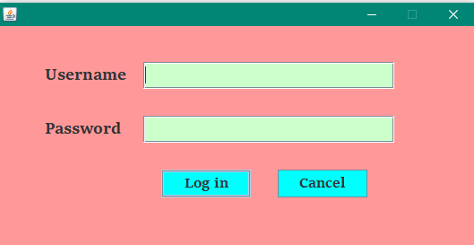

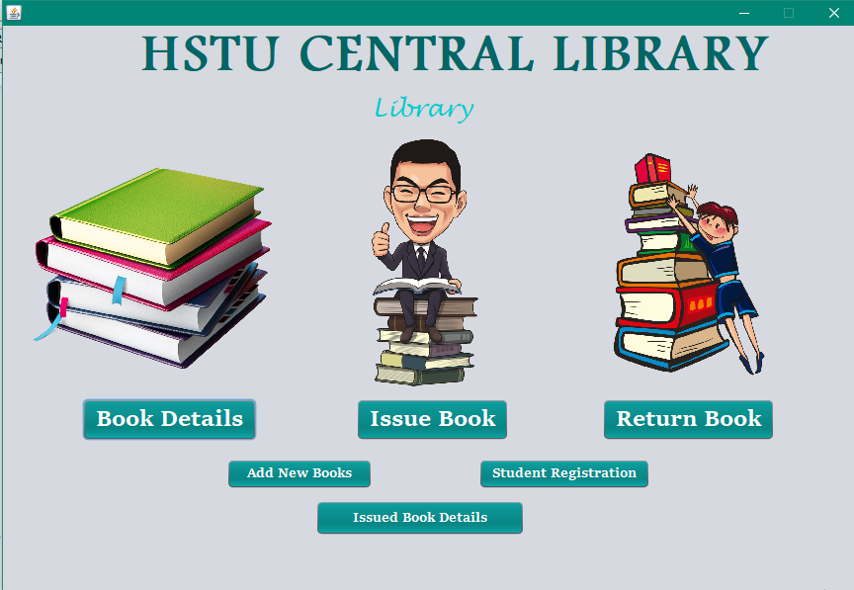

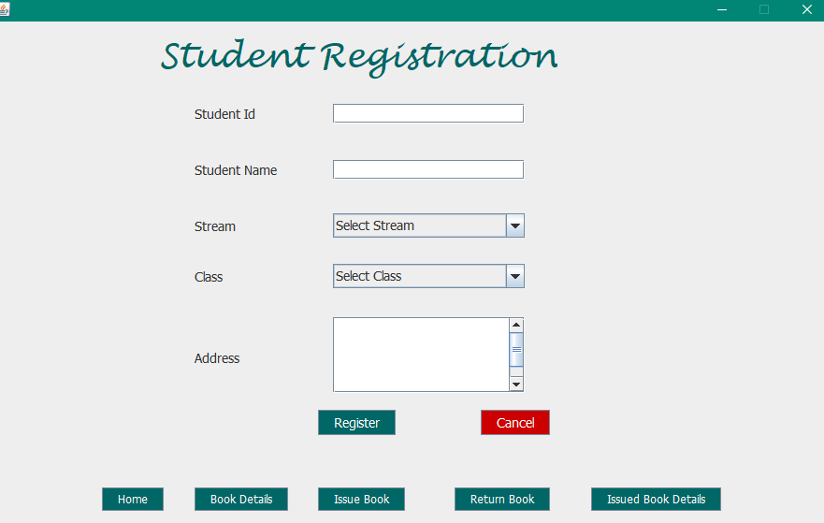

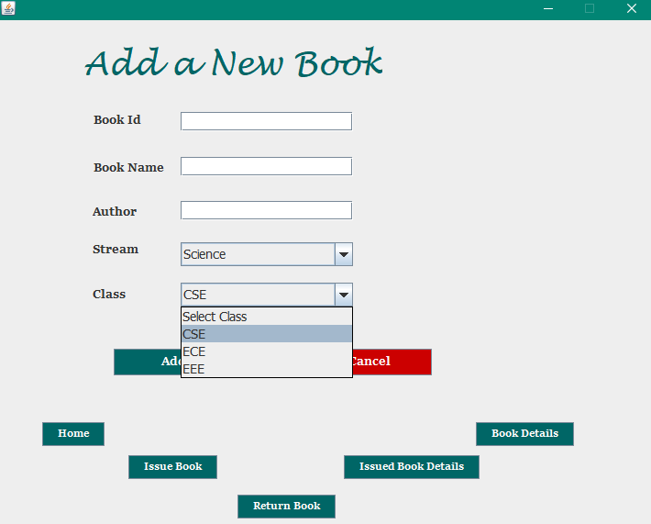

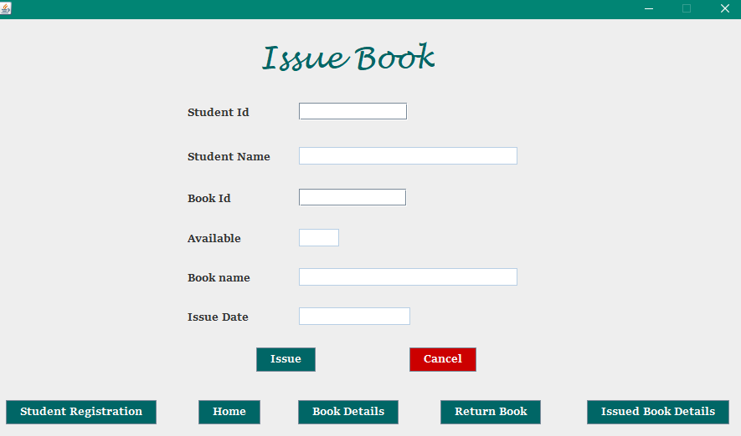

**Final output**

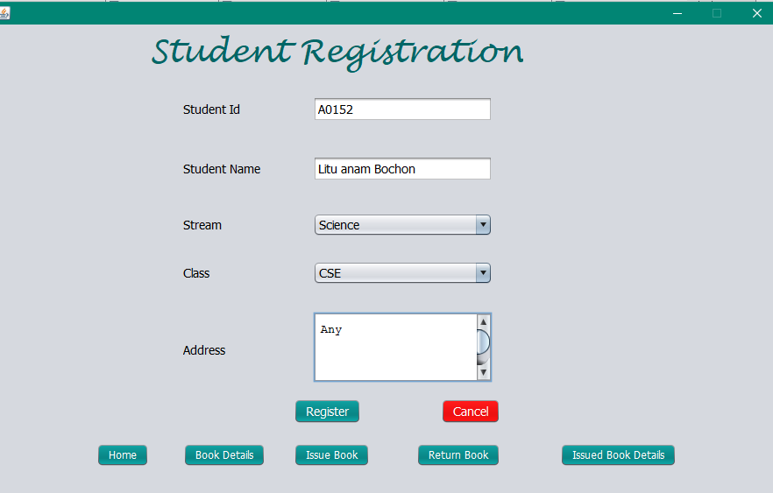

**Limitation of the project**

As a newcomer in this field, we have some limitations that we can overcome in near future.

* There may be many functionalities like number of book self, row and column number. By using this function we can easily search a book.
* Absent of digital clock and calendar.
* The UI design could be more attractive.
* GUI is not so much attractive because we didn’t use much swing components. We emphasize our work not UI design.

**Summary of the project**

This project creates an easy way in which we can find, search book is available or not. Or where the book is on a book self. This is also useful for admin panel to manipulate, update and delete data.

**লিমিটেশান এবং সামারি আমি ফাইল ব্যাক পাওয়ার পরে লিখে দিবো।**